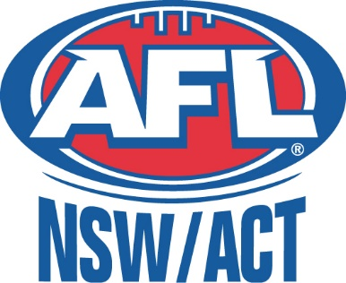

15th Dec 2024

Adam Bunce
AFL NSW/ACT

Dear Schools,

Please see below our generic risk assessment for AFL NSW/ACT run Gala Days. Please note that additional risk assessments are undertaken for larger venues, such as stadiums and copies of these can be obtained by the AFL staff member leading your day.

Gala Day Risk Assessment 2024 – Paul Kelly Cup

Risk Description | Those at Risk | Consequence | Level of Risk Prior to Management Strategies | Precautions/Management of Risk | Level of Risk After Management Strategies
Children colliding with each other or equipment/obstacles | Participants | Medium | Moderate | - Draw attention to obstacles.  - Control pace and number of students per activity.  - Designated Safe zones. | Low
Collisions with non- participants | Participants and non- participants | Minor | Low | - Ensure area is free from other users.  - Staff to remain vigilant on those potentially  entering activity space. | Low
Tripping/Falling onto hard surfaces | Participants | Medium | Moderate | - Ensure participants are aware of danger.  - Trip hazards are identified and excluded from activity zones.  - Adjusted rules may be implemented on staff  discretion. | Low
Contact with foreign material, objects or uneven playing  surfaces. | Participants | Minor | Low | - Full area inspected before commencement.  - Hazards removed. | Low
Muscular or ligament injury through excessive strains and or incorrect execution of activity. | Participants | Medium | Moderate | - Adequate dynamic and aerobic warmup.  - Appropriate equipment size/ weight.  - Clear and reinforced communication from staff to children.  - Suitable activities for age groups. | Low
Serious physical injury from excessive contact forces (concussions,  fractures etc) | Participants | Major | Low | - All activities are non- contact.  - Use of low intensity activities that are highly supervised. | Low

- 2 -

 |  |  |  | - Suitable games for respective age groups.
Negative physical response to exercise (heavy breathing, dizziness, nausea etc.) | Participants | Major | Low | - Use of low intensity activities.  - Observe physical responses.  - Remove participant from activity. | Low
Serious medical event. (hypoglycaemia, asthma attack, heart attack, anaphylaxis etc.) | Participants | Major | Moderate | - Individuals diagnosed/high risk must be made aware to staff. Careful supervision and appropriate management can then be established.  - Appropriate response actions in place – Easy access to EpiPen’s, asthma puffers, glucose etc. on site. | Low
Misuse or lack of control over equipment leading to accidental striking of other people | Participants and non- participants | Minor | Moderate | - Reinforce safety measures and game rules.  - Adequate use of space between participants.  - Appropriately manage those engaging in any negative or dangerous  behaviour. | Low
Injury through projectiles (Balls) | Participants | Medium | Moderate | - Games and activities under constant supervision.  - Use of adequate spacing for kicking.  - Modified equipment depending on age and skill levels. | Low
Cold, Hot, Wet conditions | Participants and non- participants | Medium | Low | - Staff are educated on weather conditions and its impact on activities.  - Appropriate use of clothing, hats, drink breaks, shelter/ surface  etc.  - Wet weather plan in place for each session. | Low

Australian Football League

AFL NSW/ACT Head Office, Level 1, Building/220 Bent St, Moore Park NSW 2021
www.afl.com.au
ABN 97 489 912 318

